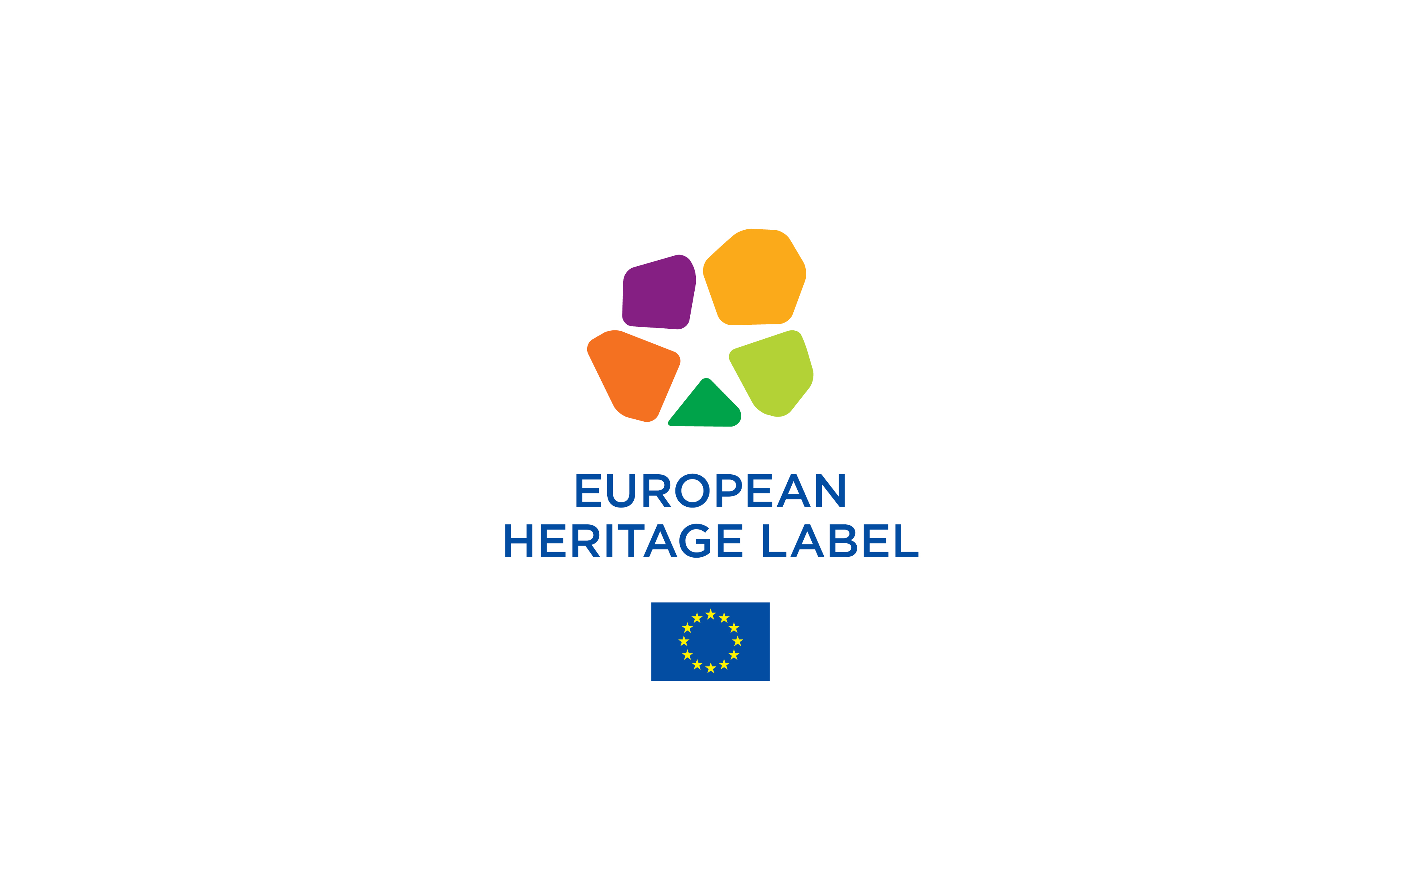

APPLICATION FORM

Selection 2021

Name of the site
Country of the site
Website
Name of the organisation
Web address of the organisation
Insert here the main picture about the site

SUMMARY OF THE APPLICATION (max 1 page)

S.1 Description of the site (max 150 words)
.
S.2 European significance of the site (max 60 words)
.
S.3 Project (max 150 words)
S.4 Operational Capacity (Max 150 words)

PART I. THE APPLICANT AND THE SITE

I.A. The applicant
Full name of the organisation
Street and number
Post code |  | City or region
Country
Name of the contact person for EHL application
Telephone
E-mail
I.B. General information about the site
Name of the site
Street and number
Post code |  | City or region
Country
Website
Social media links
Site manager
Telephone
E-mail
Legal Owner of the site
Managing authorities

I.C. Description of the site
I.C.1. Location maps and photos of the site (max 2 pages). Please caption the photographs.
I.C.2 Description and history of the site (max 400 words)

PART II. THE THREE CRITERIA

II.a. The symbolic European value of the site (400 words).

Describe clearly how your site meets one of the following objectives (or more than one if relevant):

i) The cross-border of pan-European nature of the site;

ii) The place and role of the site in European history and European integration. Its links with key european events, personalities or movements;

iii) The place and role of the site in the development and promotion of the common values that underpin European integration.

II.B The project for the site
II.B.1 Raising awareness of the European significance (max 400 words)
Outline the general strategy and objectives of your project to raise the awareness of the European significance of your site.Describe how the project will address European audiences. Present first the current situation, then your strategy and objectives. Finally, tell us what visibility and communication activities you will implement should your site receive the Label.
II.B.2 Information activities, signposting and staff training
(max 250 words)
Describe how your strategy, outlined in IIB1, will make use of information activities, signposting, staff training and other related activities to raise awareness of the European significance of the site through.Tell us first what has been done so far and then present the actions you intend to implement as of 2022. Under question II.B.8, list each activity you wish to carry out.
II.B.3 Educational activities (250 words max)
Describe the educational activities you propose, especially for young people. These should aim to increase the understanding of the common history of Europe, and also of its shared yet diverse heritage which strengthen the sense of belonging to a common space. Tell us first what has been done so far and present the actions you intend to implement in this area as of 2022. Under question II.B.8, list each activity you wish to carry out.

II.B.4 Promoting multilingual access to the site (250 words max)
Describe first how multilingual your site is at present. Then present the actions you intend to implement in order to increase multilingualism, if your site receives the Label. Under question II.B.8, list each activity you wish to carry out.

II.B.5 Being an active member of the European Heritage Label network of sites (250 words max)
Describe your expectations of becoming a member of the EHL network. Under question II.B.8, list each activity you wish to carry out.

II.B.6 Using new technologies, digital and interactive means
(250 words max)
Describe your general approach to increasing the European attractiveness of your site through the use of new technologies, digital and interactive means. Tell us first what has been done so far and then present the actions you intend to implement in this area as of 2022. Mention how you will use it to 1) attract virtual visitors, 2) enhance the in-situ interpretation of your site and 3) enhance its interpretation on the web. Under question II.B.8, list each activity you wish to carry out.

II.B.7 Artistic and cultural activities, including contemporary creation (250 words max, optional to answer)

Describe your approach in the area of artistic and cultural activities - including contemporary creation - that foster the mobility of European culture professionals, artists and collections, stimulate intercultural dialogue and encourage linkage between heritage and contemporary creation and creativity.Tell us first what has been done so far and then present the actions you intend to implement as of 2022 Under question II.B.8, list each activity you wish to carry out.

II.B.8 The listing of activities to implement your project
Activity | Present situation | Details of actions | Intended outcome | Start date of action | Indicator
Activity 2.1: |  | Action 1
 |  | Action 2
 |  | Action 3
Activity 2.2: |  | Action 1
 |  | Action 2
 |  | Action 3
Activity 2.3: |  | Action 1
 |  | Action 2
 |  | Action 3

II.C The organisational capacity of the site
II.C.1 Management of the site (300 words max)
Outline the overall management plan for your site and specify if further developments are planned within the next four years.

II.C.2 Preservation of the site (250 words max)
Outline the legal protection your site enjoys at present, then describe the current state of conservation and whether any conservation work is planned within the next four years.
.

II.C.3 Reception facilities, visitors' information and signposting
(250 words max)
Describe the current reception facilities and list any future improvements you are planning to undertake within the next four years.

II.C.4 Public access (250 words max)
Describe how you ensure access to your site for the widest possible public. Mention any future site adaptations or staff training you are planning to undertake within the next four years.

II.C.5 Special attention for young people (250 words max)
If young people have privileged or prioritised access to the site, present it here. Then describe any future activities you are planning to undertake in this area within the next four years.

II.C.6 Sustainable tourism (250 words max)
Present the marketing plan for the site as a tourist destination. Then describe any future actions you are planning to undertake in this area within the next four years.

II.C.7 Communication of the European significance of the site
(250 words max)
Outline your current communication strategy for the site. Then present additional communication activities to highlight its European significiance which you plan to undertake in this area within the next four years.

II.C.8. Environmentally friendly management of the site (250 words max)
Outline your approach to integrating the protection of the environment in your day-to day management of the site and in the way you welcome visitors. Then present any future actions you are planning to undertake in this area within the next four years.

II.C.9 The international outreach and recognition of your site
(250 words max)
Describe the current international networks your site is part of and any international recognition it currently has. Then present any other international outreach you are planning to undertake within the next four years, in addition to the EHL.
II.C.10. Operating budget of the site (maximum 1 page)
Outline the current operating budget for the overall management of the site (conservation works excluded). Please include: annual running costs, communication costs, cultural, educational, research, networking activities costs. Identify also the principal sources of income available to the site.

Before filling the form, read the guidelines available at http://ec.europa.eu/programmes/creative-europe/actions/heritage-label/apply_en.htm
Anytime a max number of words is mentioned in the form, it has to be applied either to the English version of your application or to the other language of your application.

